Final Project Design Phase
Computer Science - Week 11
Oct 3, 2026 - Version 0.0.4

For complete instructions and project ideas, refer to the assignment in Canvas. Specifically, review the final project requirements before you continue below. If you have not reviewed the project requirements in Canvas (you might have to go to the modules view and check the current or past week's content), you will not be able to properly complete the parts below. In addition, it may be helpful to review the information on this Drafter documentation page.

0) Project Planning and Preparation
Successful programmers spend time planning before they begin coding. After reviewing the project requirements, answer the following questions to help guide your design and development process.
- What concepts from class or previous assignments might help you complete this project? Which programming concepts (loops, conditionals, lists, classes, etc.) do you expect to use? What programming skills do you want to improve while completing this project?
I am most definitely expecting to utilize Python dataclasses to manage state classes. I also expect to use conditional statements for a variety of topics in this project. For Loops will also play a big part in my project so that lab records can be iterated over. Drafter UI components (things like TextBox) also will be utilized.

- Which parts of the project do you expect to be the easiest for you? The hardest? Why?
I expect the easiest parts of this project to be creating the basic Drafter routes and more-basic functions for my project as these will reflect what I have learned in BlockPy. As for the most difficult part of the project, I think that parsing different chemical equations will present a big challenge to me.

- Even though you have not yet designed the final project, estimate which tasks will likely require the most time and effort? Which features or components should be implemented first?
I think that designing the functions that will perform the stoichiometry calculations will take a lot of time. Also, ensuring that all of the route parameters and states are in check may take me a long time, as this is not one of my strongest areas.

- What distractions might interfere with your work and how will you minimize them? What resources will you need available while working? What questions, if any, do you still have about the assignment requirements?
A big one for me is social media. I tend to delete social media on weeks that I have a lot of coursework, so I’m not too worried about getting too distracted. The Discord channel will be a pivotal resource to me in case I have any questions outside of office hours.

1) Site Diagram
Create a mock-up of your planned website. We suggest you make the mockup on paper, although you can also use software like PowerPoint or Slides to make a mockup. There is other design software that could also be used, but we strongly encourage you to keep it simple. Do not spend more than 15-30 minutes detailing the mock-up. Your goal should be to make a very quick and dirty diagram, to show that you have some kind of idea.

We recommend drawing each page as a rectangle, and laying out the text, buttons, and other components inside. Then, use arrows to indicate links between pages. Label each page the way you will name each function, and then put labels on the arrows to indicate what the button links. Also write down any parameters that should come into the pages.

In addition to the pages and routes, write down what fields your `State` will have, both their names and types. Think clearly about what data will need to be persistent across the entire website.

Add photo(s) or screenshot(s) of your website mock-up and labeled diagram on the next page.

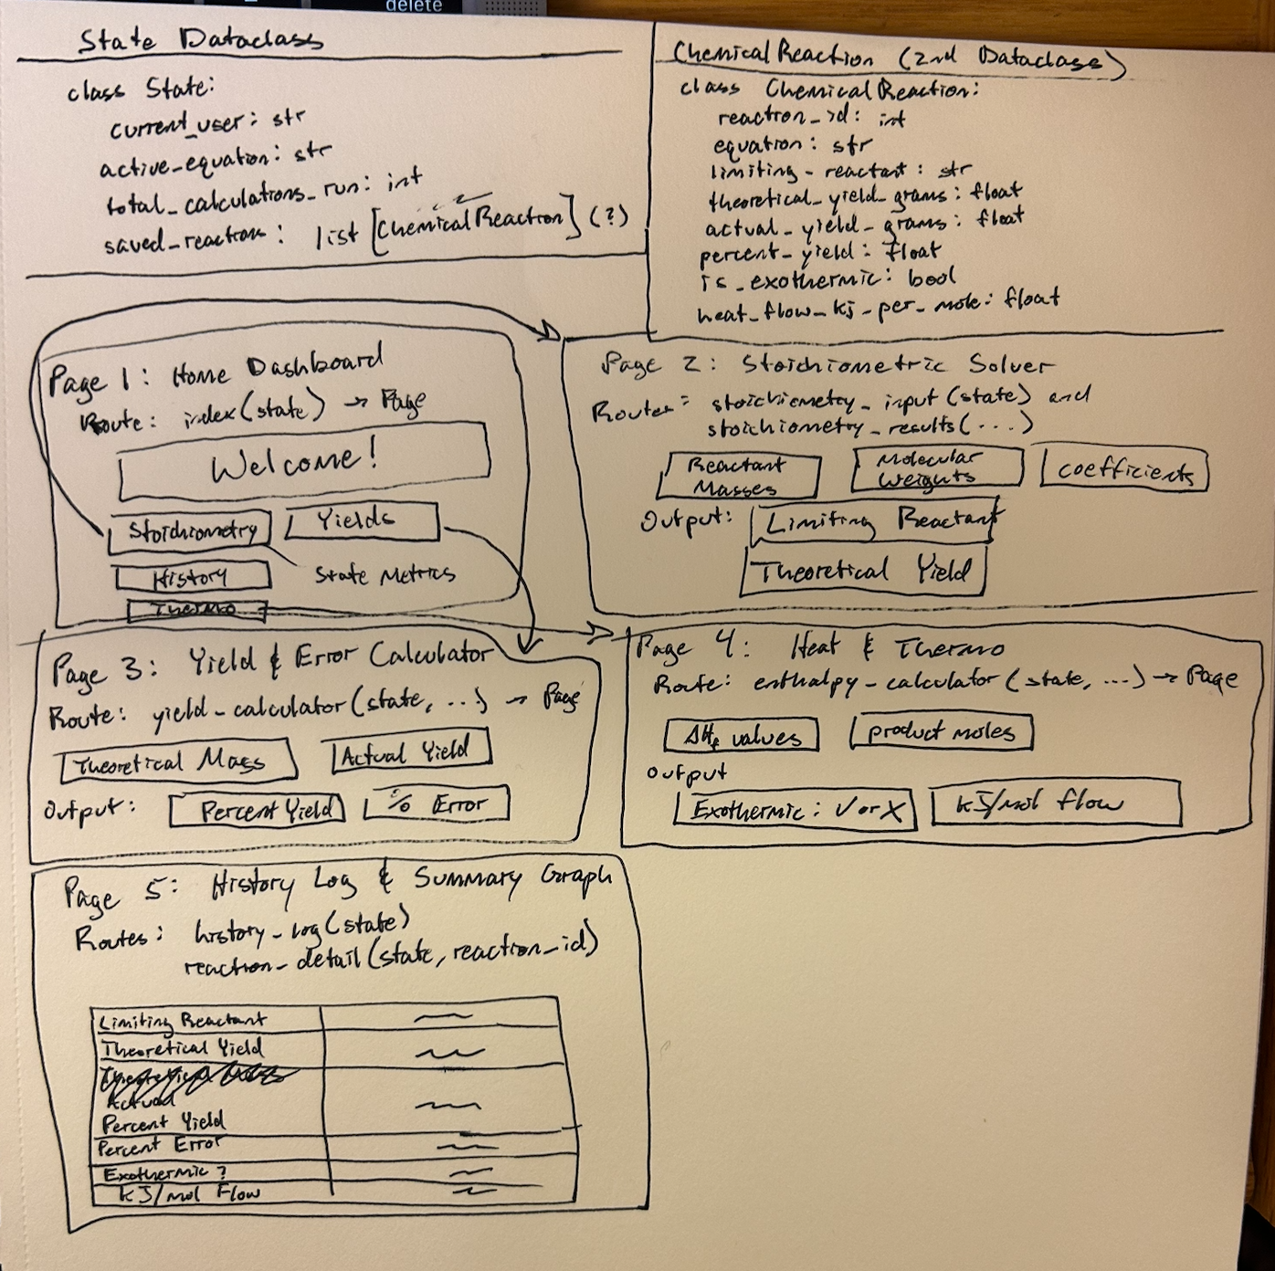

2) Implementing Requirements
This table should serve as a draft for how you will implement the requirements into your final project. You may change your ideas later on, but your final site must fulfill all the requirements.

Requirement | Implementation
Purpose/Functionality  A 1-2 sentence description of the purpose or functionality of your site | An automated chemistry assistant web application designed for Chemical Engineering and General Chemistry students. It streamlines some tedious lab calculations in order to highlight the actual concept at hand in the lab.
State Dataclass Attributes  Minimum of 4 attributes, one of which must be a list/dict of instances of your second dataclass.  Briefly describe each attribute, its type, and how it will be meaningfully modified throughout the site. | current_user (str): Active student’s name, which is modified in settings route.  active_equation (str): Current equation string; modified on form submit.  Total_calculations_run (int): Counter incremented on every execution  Saved_reactions (list[ChemicalReactions]): List of second dataclass instances, modified by appending new lab records or clearing history.  Dark_mode_enabled (bool): UI toggle modified with a checkbox
Second Dataclass  Your second dataclass, including its attributes, their types, and how they will be meaningfully modified (if they are modified) | ChemicalReaction dataclass with attributes: reaction_id (int), equation (str), limiting_reactant (str), theoretical_yield_grams (float), percent_yield (float), is_exothermic (bool), and heat_flow_kj_per_mol (float). Instances are instantiated during calculation routes, stored in state.saved_reactions. Edited in the detail view.
Routes (minimum 7)  The names of your route functions | index(state: State) -> Page  stoichiometry_input(state: State) -> Page  stoichiometry_results(State class and a bunch of different weights of reactants)->Page  yield_calculator(state: State, theoretical_grams: float, actual_grams: float) -> Page  enthalpy_calculator(state: State, h_react: float, h_prod: float, moles: float)->Page  history_log(state: State)->Page  reaction_detail(state: State, reaction_id: int)->Page
Pages (minimum 5)  A brief description of the pages in your site | Home Dashboard: System summary, tool links  Stoichiometric Analysis Page: Reagent mass/molar solver and limiting reagent finder  Yield and Error: percent yield and error computation  Heat and Thermo: Reaction enthalpy and exothermic check  History and Summary: a table-like view of logged records
User Input (minimum 3)  Description of user input components (TextBox, TextArea, CheckBox, or SelectBox) and their purposes  For more information on these input types, see Drafter Documentation. | TextBox: For entering numerical reagent masses, molecular weights, and yields  SelectBox: For choosing reaction types (i.e. Synthesis or combustion)  CheckBox: for toggling dark mode and saving result to log  TextArea: For entering multi-line chemical equation notes
If Statements (minimum 3)  Brief description of what will be evaluated in your if statements and how they will meaningfully change the logic of the site | Limiting reagent check: if (moles_a / coeff_a) < (moles_b / coeff_b): determines which species limits theoretical yield of the products.  Exothermic Status: if net_delta_h < 0: sets is_exothermic = True  Zero Division Guard: if theoretical_yield <= 0: validates inputs to prevent crash when computing percent yield.
Loop (minimum 1)  This loop must iterate over the list/dict of dataclass instances in your State attribute.  Description of this loop and why it is meaningful to the site | For reaction in state.saved_reactions: iterates over the list of ChemicalReaction dataclass instances in the State to dynamically construct HTML summary rows in history_log() and computer the overall average percent yield across all recorded lab trials.

LLM Conversation
If you used an LLM in any part of this work, copy and paste every part of that conversation below. Otherwise, you may be given a zero for the assignment. Obviously, these words will not all be yours, and this is the exception to the requirement at the top of this assignment that all responses be in your own words. If you did not use an LLM to assist you in this assignment, simply say so below.
I did not utilize AI for this part of the assignment.

Final Submission
When you are finished, download this file as a Word Document (docx) and upload the file to the appropriate assignment on Canvas.

